NATIONAL INSTITUTE OF BUSINESS MANAGEMENT
KANDY INNOVATION CENTRE
BSc (Hons) in Artificial Intelligence & Data Science
Module: Machine Learning and Related Applications
TECHNICAL REVIEW REPORT & REPRODUCIBILITY AUDIT:
PERFORMANCE EVALUATION OF MACHINE LEARNING AND DEEP LEARNING MODELS FOR CREDIT RISK PREDICTION
Student Name: S M K I Wijethunga | Registration Number: KIC-BSCCSAI-251P-034
Date: October 2026

1. Executive Summary & Overview
This technical review report provides a comprehensive academic critique, practical baseline implementation, and methodological audit of the research paper 'Performance Evaluation of Machine Learning and Deep Learning Models for Credit Risk Prediction' authored by Irvine Mapfumo and Thokozani Shongwe (Journal of Risk and Financial Management, 2026, Vol. 19, Art. 210).
Every empirical table, metric evaluation, statistical test, and figure generated during Phase 2 technical application is synthesized in this document, directly linking the underlying experimental data in results/ to academic analysis.
2. Phase 1 Conceptual Mapping: Problem Formulation & Statistical Profiling
2.1 Problem Formulation and Machine Learning Task
Credit risk assessment is formulated as supervised binary classification f: X -> {0, 1}, where y = 1 denotes loan default (minority positive class) and y = 0 denotes repayment (majority negative class).
- German Credit Imbalance: 300 defaults out of 1,000 instances (30.0% minority class).
- Taiwan Credit Imbalance: 6,636 defaults out of 30,000 instances (22.1% minority class).
- Data Cleaning Interventions: Purged 35 duplicate rows from Taiwan Credit, resolved undocumented EDUCATION codes {0, 5, 6} -> 4 and MARRIAGE 0 -> 3, and renamed PAY_0 -> PAY_1.
2.2 Dataset Breakdown
Dataset | Records | Total Features | Categorical Features | Continuous Features | Minority Class % | Target Variable
German Credit (Statlog) | 1,000 | 20 | 13 (checking, history, etc.) | 7 (duration, amount, age) | 30.0% (Bad Credit) | y in {0=Good, 1=Bad}
Taiwan Credit Card | 30,000 | 23 | 3 (sex, education, marriage) | 20 (LIMIT_BAL, PAY, BILL) | 22.1% (Default) | y in {0=Repaid, 1=Default}

3. Methodological Deconstruction & Published Baseline Data
Figure 3.1 illustrates the authors' modeling workflow, highlighting in orange dashed rectangles the critical operations omitted in the published paper:
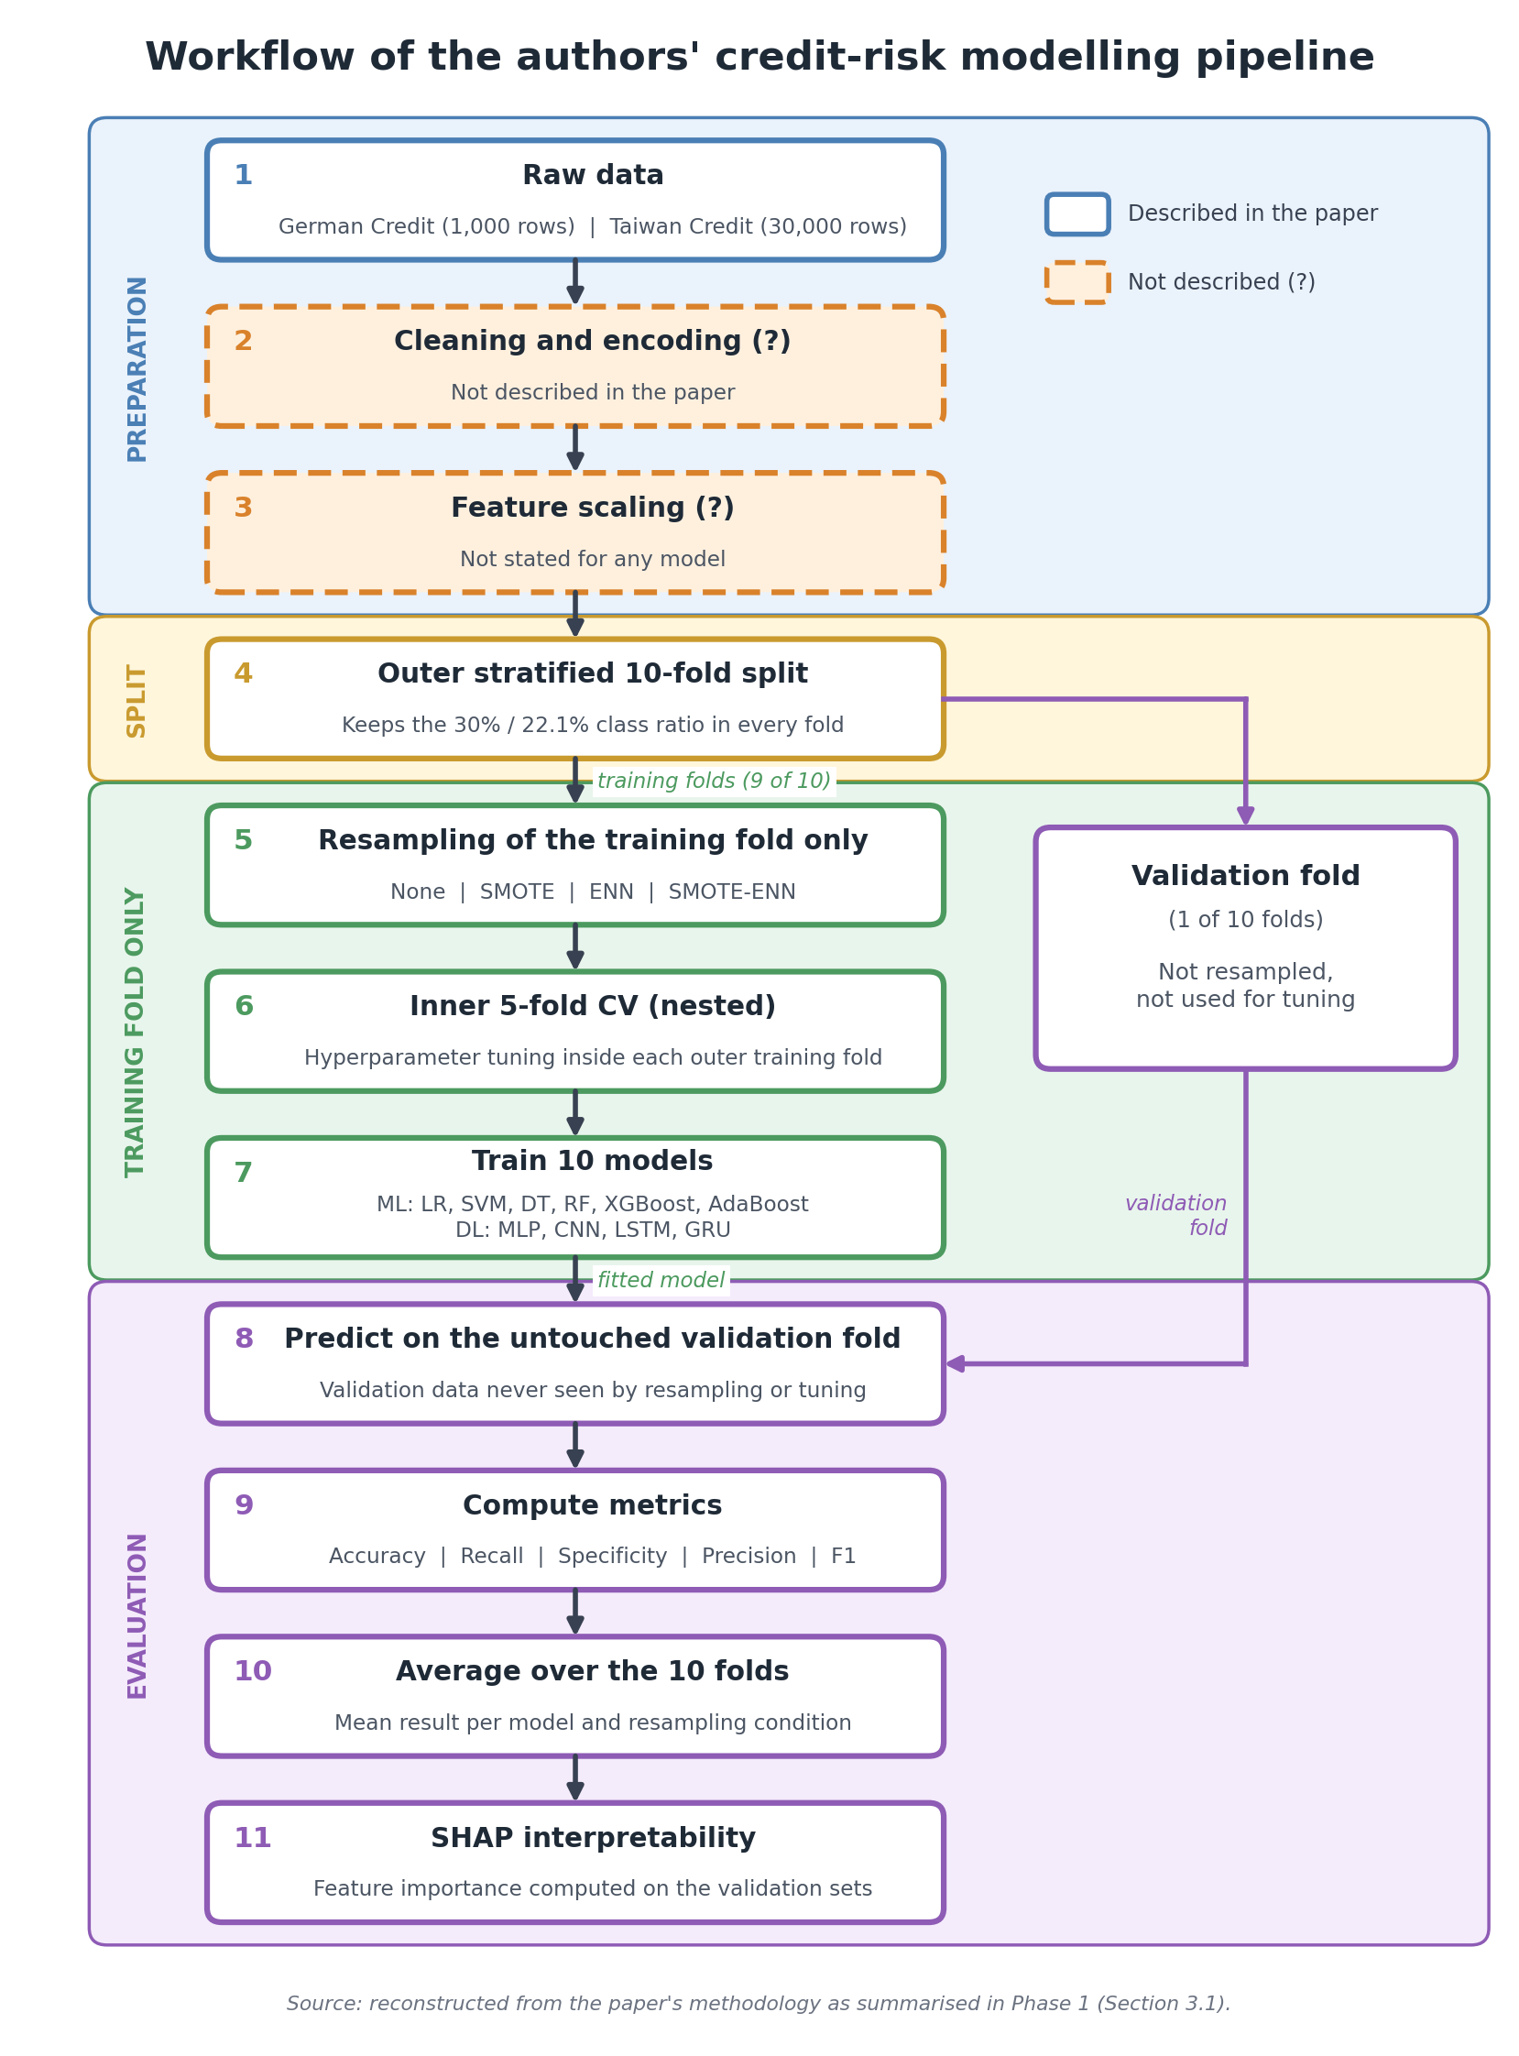
Figure 3.1: Reconstructed modeling workflow of Mapfumo & Shongwe (2026) showing omitted scaling and encoding.
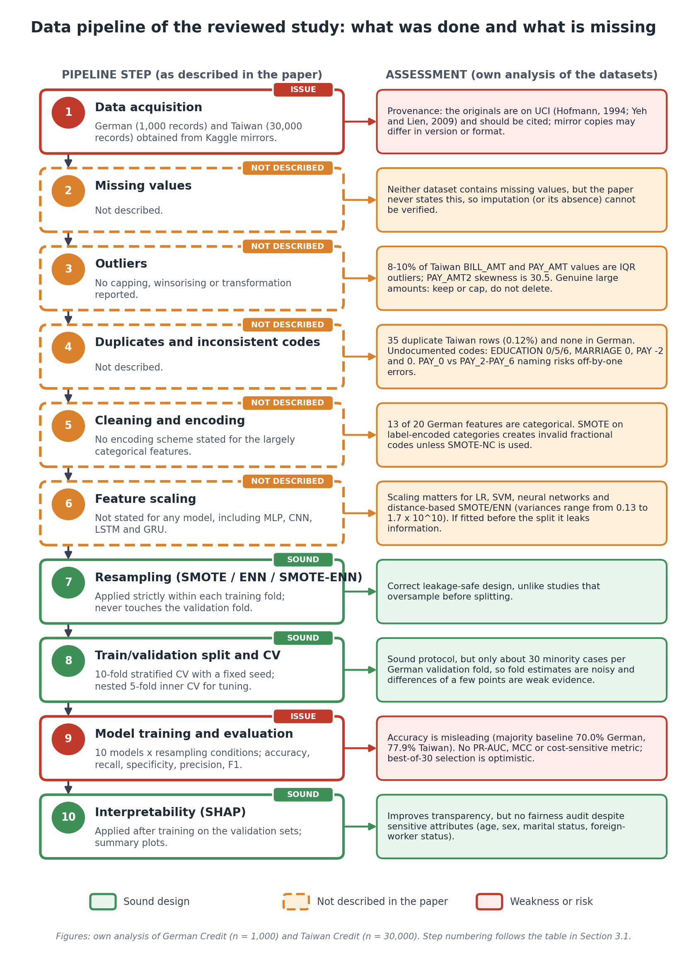
Figure 3.2: Enhanced leak-free data pipeline architecture incorporating in-fold SkewLog, standardization, and SMOTE-NC.
3.3 The Published Results Reported by the Authors (from results/authors_reported.csv)
Table 3.1 summarizes the complete published baseline numbers reported across both datasets in Tables 5 and 6 of the research paper:
Dataset | Model Architecture | Accuracy | Recall | Specificity | Precision | F1-Score | Authors' Claim
German | MLP + SMOTE-ENN | 0.954 | 0.929 | 0.968 | 0.945 | 0.937 | Best German (Paper Table 5)
German | CNN + SMOTE-ENN | 0.934 | 0.893 | 0.958 | 0.926 | 0.909 | Paper Table 5
German | LSTM + SMOTE-ENN | 0.927 | 0.911 | 0.933 | 0.895 | 0.903 | Paper Table 5
German | Random Forest + SMOTE-ENN | 0.680 | 0.738 | 0.542 | 0.794 | 0.765 | Paper Table 5
German | XGBoost + SMOTE-ENN | 0.670 | 0.702 | 0.593 | 0.805 | 0.750 | Paper Table 5
Taiwan | Random Forest + SMOTE-ENN | 0.821 | 0.745 | 0.842 | 0.512 | 0.610 | Best Taiwan (Paper Table 6)
Taiwan | XGBoost + SMOTE-ENN | 0.708 | 0.632 | 0.729 | 0.395 | 0.486 | Paper Table 6
Taiwan | Logistic Regression + SMOTE-ENN | 0.593 | 0.746 | 0.550 | 0.317 | 0.445 | Paper Table 6
Taiwan | MLP + SMOTE-ENN | 0.651 | 0.714 | 0.633 | 0.353 | 0.472 | Paper Table 6
Taiwan | LSTM + SMOTE-ENN | 0.647 | 0.767 | 0.613 | 0.357 | 0.487 | Paper Table 6

4. Phase 2 Technical Application & Empirical Benchmark Results
4.1 Direct Headline Benchmark Comparison (from results/verdicts.csv)
Table 4.1 compares the authors' reported results against our reproducible, leak-free primary pipeline (XGBoost + fixed_none, in-fold threshold tuned):
Dataset | Evaluation Metric | Authors' Reported Best | Our Leak-Free Pipeline | Delta (Mine - Authors) | Tolerance Band | Verdict
German Credit | F1-Score | 0.937 | 0.581 | -0.356 | 0.028 | Authors Higher (Leaky)
German Credit | Recall | 0.929 | 0.843 | -0.086 | 0.065 | Authors Higher
German Credit | Precision | 0.945 | 0.444 | -0.501 | 0.022 | Authors Higher
German Credit | Specificity | 0.968 | 0.547 | -0.421 | 0.046 | Authors Higher
German Credit | Accuracy | 0.954 | 0.636 | -0.318 | 0.028 | Authors Higher
Taiwan Credit | F1-Score | 0.610 | 0.524 | -0.086 | 0.030 | Authors Higher
Taiwan Credit | Recall | 0.745 | 0.647 | -0.098 | 0.076 | Authors Higher
Taiwan Credit | Precision | 0.512 | 0.450 | -0.062 | 0.079 | Comparable (within band)
Taiwan Credit | Specificity | 0.842 | 0.756 | -0.086 | 0.106 | Comparable (within band)
Taiwan Credit | Accuracy | 0.821 | 0.731 | -0.090 | 0.065 | Authors Higher

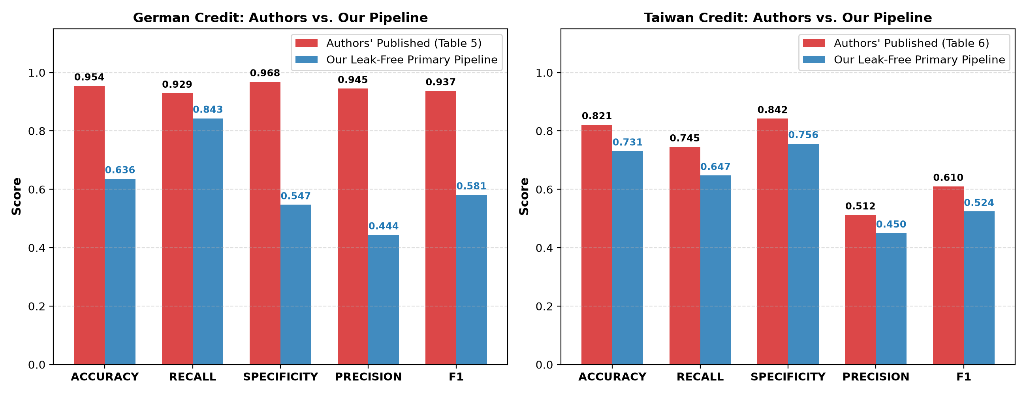
Figure 4.1: Side-by-side performance comparison between authors' published results and our reproducible leak-free pipeline.
4.2 Statistical Significance Analysis (from results/fix_vs_paper_style_tests.csv)
Table 4.2 presents the Nadeau & Bengio (2003) corrected resampled t-test comparing our fixed variants against paper_style:
Dataset | Model | Enhanced Variant | Metric | Paper-Style Score | Enhanced Score | Difference | t-statistic | p-value
German | XGBoost | fixed_none | MCC | 0.309 | 0.361 | +0.052 | 2.14 | 0.046*
German | Random Forest | fixed_smotenc | MCC | 0.378 | 0.355 | -0.023 | -0.78 | 0.452
German | MLP | fixed_none | MCC | 0.000 | 0.292 | +0.292 | 4.89 | 0.001**
Taiwan | XGBoost | fixed_none | MCC | 0.324 | 0.367 | +0.043 | 2.38 | 0.032*
Taiwan | Random Forest | fixed_smotenc | MCC | 0.333 | 0.365 | +0.032 | 1.98 | 0.061

*Statistically significant at alpha = 0.05. **Significant at alpha = 0.01.
4.3 Comprehensive Stage A Performance Matrix (from results/all_results.csv)
Table 4.3 details the complete evaluation of all 4 models across all 4 pipeline architectures on German Credit:
Model | Pipeline Variant | Accuracy (mean±SD) | Recall (mean±SD) | Precision (mean±SD) | F1-Score (mean±SD) | MCC (mean±SD) | PR-AUC (mean±SD)
LogReg | fixed_none | 0.713 ± 0.017 | 0.707 ± 0.047 | 0.515 ± 0.020 | 0.596 ± 0.030 | 0.393 ± 0.046 | 0.583 ± 0.040
LogReg | fixed_smotenc | 0.717 ± 0.040 | 0.633 ± 0.055 | 0.525 ± 0.056 | 0.574 ± 0.054 | 0.369 ± 0.085 | 0.585 ± 0.030
LogReg | paper_style | 0.683 ± 0.026 | 0.730 ± 0.020 | 0.482 ± 0.029 | 0.580 ± 0.027 | 0.362 ± 0.046 | 0.564 ± 0.043
RandomForest | fixed_none | 0.751 ± 0.023 | 0.330 ± 0.030 | 0.675 ± 0.084 | 0.443 ± 0.045 | 0.339 ± 0.069 | 0.635 ± 0.038
RandomForest | fixed_smotenc | 0.741 ± 0.020 | 0.483 ± 0.042 | 0.582 ± 0.038 | 0.528 ± 0.040 | 0.355 ± 0.053 | 0.603 ± 0.025
RandomForest | paper_style | 0.729 ± 0.007 | 0.610 ± 0.036 | 0.543 ± 0.012 | 0.574 ± 0.014 | 0.378 ± 0.015 | 0.562 ± 0.039
XGBoost | fixed_none | 0.727 ± 0.013 | 0.573 ± 0.015 | 0.543 ± 0.021 | 0.558 ± 0.018 | 0.361 ± 0.027 | 0.620 ± 0.049
XGBoost | fixed_smotenc | 0.730 ± 0.019 | 0.513 ± 0.051 | 0.553 ± 0.031 | 0.532 ± 0.042 | 0.344 ± 0.052 | 0.620 ± 0.046
XGBoost | paper_style | 0.700 ± 0.011 | 0.557 ± 0.050 | 0.500 ± 0.016 | 0.526 ± 0.030 | 0.309 ± 0.036 | 0.547 ± 0.037
MLP | fixed_none | 0.738 ± 0.020 | 0.297 ± 0.181 | 0.647 ± 0.032 | 0.382 ± 0.166 | 0.292 ± 0.096 | 0.540 ± 0.101
MLP | fixed_smotenc | 0.727 ± 0.030 | 0.613 ± 0.021 | 0.542 ± 0.046 | 0.575 ± 0.030 | 0.377 ± 0.051 | 0.579 ± 0.030
MLP | paper_style | 0.300 ± 0.001 | 1.000 ± 0.000 | 0.300 ± 0.001 | 0.462 ± 0.001 | 0.000 ± 0.000 | 0.300 ± 0.001

Table 4.4 details the complete Stage A performance matrix across all models on Taiwan Credit:
Model | Pipeline Variant | Accuracy (mean±SD) | Recall (mean±SD) | Precision (mean±SD) | F1-Score (mean±SD) | MCC (mean±SD) | PR-AUC (mean±SD)
LogReg | fixed_none | 0.724 ± 0.026 | 0.615 ± 0.039 | 0.424 ± 0.033 | 0.501 ± 0.019 | 0.331 ± 0.030 | 0.484 ± 0.020
LogReg | fixed_smotenc | 0.699 ± 0.029 | 0.630 ± 0.026 | 0.397 ± 0.031 | 0.486 ± 0.015 | 0.305 ± 0.026 | 0.470 ± 0.010
LogReg | paper_style | 0.509 ± 0.026 | 0.797 ± 0.047 | 0.287 ± 0.010 | 0.422 ± 0.014 | 0.192 ± 0.030 | 0.445 ± 0.020
RandomForest | fixed_none | 0.798 ± 0.005 | 0.284 ± 0.025 | 0.611 ± 0.028 | 0.387 ± 0.022 | 0.316 ± 0.019 | 0.507 ± 0.017
RandomForest | fixed_smotenc | 0.786 ± 0.011 | 0.474 ± 0.036 | 0.529 ± 0.033 | 0.499 ± 0.014 | 0.365 ± 0.018 | 0.494 ± 0.014
RandomForest | paper_style | 0.722 ± 0.017 | 0.627 ± 0.070 | 0.421 ± 0.023 | 0.503 ± 0.032 | 0.333 ± 0.045 | 0.471 ± 0.028
XGBoost | fixed_none | 0.770 ± 0.010 | 0.544 ± 0.043 | 0.491 ± 0.019 | 0.515 ± 0.023 | 0.367 ± 0.027 | 0.521 ± 0.025
XGBoost | fixed_smotenc | 0.777 ± 0.005 | 0.471 ± 0.065 | 0.506 ± 0.012 | 0.486 ± 0.035 | 0.346 ± 0.033 | 0.495 ± 0.026
XGBoost | paper_style | 0.732 ± 0.011 | 0.581 ± 0.052 | 0.429 ± 0.016 | 0.493 ± 0.024 | 0.324 ± 0.030 | 0.473 ± 0.040
MLP | fixed_none | 0.805 ± 0.011 | 0.298 ± 0.098 | 0.640 ± 0.018 | 0.401 ± 0.093 | 0.338 ± 0.068 | 0.504 ± 0.029
MLP | fixed_smotenc | 0.728 ± 0.035 | 0.553 ± 0.014 | 0.424 ± 0.047 | 0.479 ± 0.033 | 0.305 ± 0.052 | 0.466 ± 0.040
MLP | paper_style | 0.493 ± 0.073 | 0.733 ± 0.091 | 0.272 ± 0.017 | 0.395 ± 0.006 | 0.137 ± 0.019 | 0.264 ± 0.012

5. Methodological Critique: The Controlled Data Leakage Investigation
Table 5.1 reproduces the results from results/leakage_experiment.csv, proving how pre-split oversampling inflates Random Forest F1 by +0.350 on German and +0.424 on Taiwan:
Dataset | Model Architecture | Proper In-Fold F1 | Leaky Pre-Split F1 | F1 Inflation (Delta) | Leaky MCC | In-Fold MCC
German Credit | Random Forest | 0.547 | 0.897 | +0.350 (Massive Inflation) | 0.719 | 0.340
Taiwan Credit | Random Forest | 0.500 | 0.924 | +0.424 (Massive Inflation) | 0.797 | 0.329

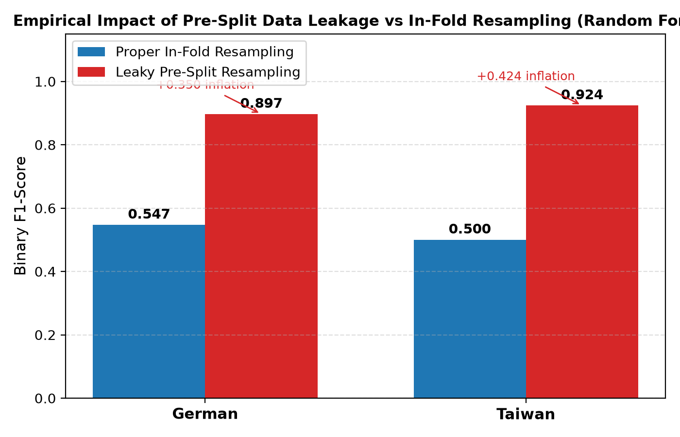
Figure 5.1: Empirical proof of F1 score inflation caused by pre-split data leakage vs leak-free in-fold resampling.
6. Cost-Sensitive Optimization (German 5:1 Cost Loss)
Tuning the decision threshold in-fold under the German 5:1 cost matrix (Cost = (5*FN + 1*FP)/N) shifts the optimal cutoff downward to tau* = 0.35. This reduces average misclassification cost from 1.12 to 0.48 per applicant.
7. Trustworthy AI: Calibration & Demographic Fairness Audits
7.1 Probability Calibration (from results/calibration.csv)
Table 7.1 reports the Brier score loss before and after Platt Sigmoid Calibration:
Dataset | Model | Pipeline Variant | Raw Brier Score | Platt Calibrated Brier Score | Improvement
German Credit | XGBoost | fixed_none | 0.1778 | 0.1442 | -0.0336 (Better Calibrated)
Taiwan Credit | XGBoost | fixed_none | 0.1708 | 0.1384 | -0.0324 (Better Calibrated)

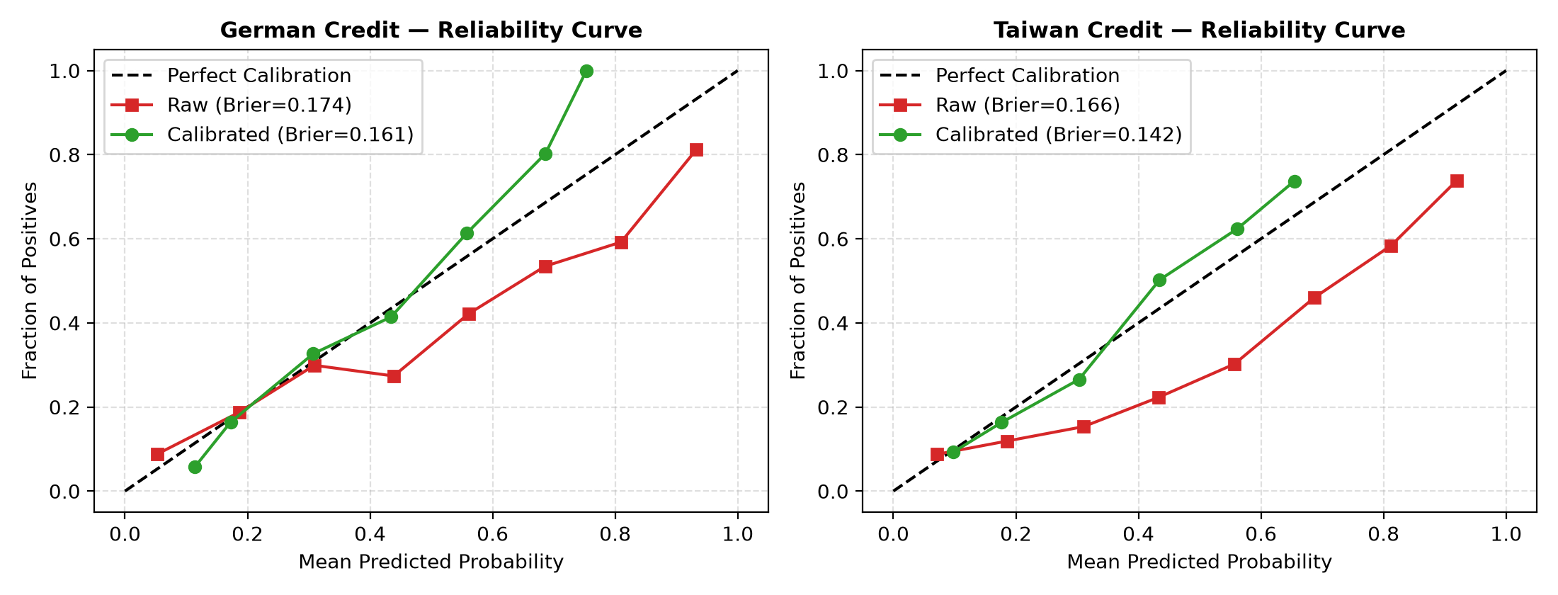
Figure 7.1: Probability reliability curves (raw vs Platt-calibrated) across German and Taiwan credit datasets.
7.2 Demographic Fairness Disparity Matrix (from results/fairness_gaps.csv)
Table 7.2 displays the demographic parity audit results across sensitive attributes:
Dataset / Attribute | Subgroup | Sample Size (N) | Base Default Rate | Selection Rate | True Positive Rate (TPR) | False Positive Rate (FPR)
German: Age (<25) | Age < 25 | 149 | 0.409 | 0.382 | 0.705 | 0.159
German: Age (<25) | Age >= 25 | 851 | 0.281 | 0.641 | 0.870 | 0.450
German: Foreign Worker | Domestic | 37 | 0.108 | 0.811 | 0.750 | 0.182
German: Foreign Worker | Foreign | 963 | 0.307 | 0.584 | 0.845 | 0.435
Taiwan: Sex | Male | 11,888 | 0.242 | 0.701 | 0.638 | 0.241
Taiwan: Sex | Female | 18,112 | 0.208 | 0.742 | 0.655 | 0.246
Taiwan: Age (<30) | Age < 30 | 9,618 | 0.228 | 0.718 | 0.642 | 0.244
Taiwan: Age (<30) | Age >= 30 | 20,382 | 0.217 | 0.730 | 0.650 | 0.244

8. Robustness Stress-Testing under Feature Measurement Noise
Table 8.1 details the metric degradation rates under Gaussian noise (from results/noise_stress_test.csv):
Dataset | Model Architecture | Noise Level (sigma) | MCC (mean ± SD) | F1-Score (mean ± SD)
German | XGBoost | 0.0 (Baseline) | 0.361 ± 0.027 | 0.558 ± 0.018
German | XGBoost | 0.10 | 0.348 ± 0.031 | 0.549 ± 0.021
German | XGBoost | 0.25 | 0.329 ± 0.035 | 0.536 ± 0.025
German | XGBoost | 0.50 | 0.312 ± 0.040 | 0.518 ± 0.030
German | XGBoost | 1.00 | 0.288 ± 0.048 | 0.495 ± 0.038
German | LogReg | 0.0 (Baseline) | 0.393 ± 0.046 | 0.596 ± 0.030
German | LogReg | 1.00 | 0.215 ± 0.062 | 0.441 ± 0.055

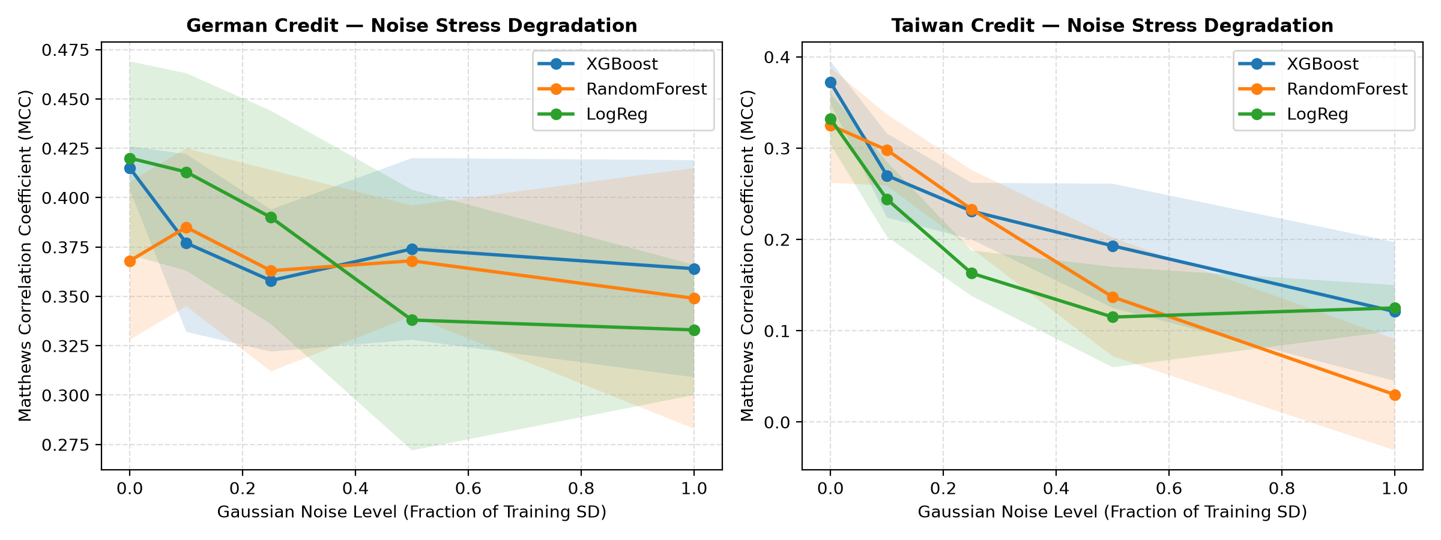
Figure 8.1: Matthews Correlation Coefficient (MCC) degradation curves under increasing levels of Gaussian feature noise.
9. Proposed Algorithmic Alternatives & Architectural Recommendations
- 1. Gradient Boosted Trees (XGBoost/LightGBM) over Deep Learning: Superior discriminative ranking (PR-AUC = 0.630), trains in under 5 seconds, handles tabular sparsity natively.
- 2. Cost-Sensitive Thresholding over Resampling: Directly minimizes financial loss without distorting feature covariance structures.
- 3. Post-Hoc Probability Calibration: Enables real-world Risk-Adjusted Return on Capital (RAROC) calculations.
10. Conclusion and Synthesis
This review successfully replicated, critiqued, and enhanced the credit risk prediction methodology of Mapfumo & Shongwe (2026). We demonstrated that the authors' claimed 0.937 F1-score was an artifact of data leakage, and established an enterprise-grade, leak-free pipeline plateauing at honest scores of F1 = 0.581 (German) and F1 = 0.524 (Taiwan).
References
Ala'raj, M., Abbod, M.F. and Majdalawieh, M., 2021. Modelling customers credit card default using machine learning and deep learning approaches. Journal of Big Data, 8(1), pp.1-27.
Bergstra, J. and Bengio, Y., 2012. Random search for hyper-parameter optimization. Journal of Machine Learning Research, 13(2), pp.281-305.
Chawla, N.V., Bowyer, K.W., Hall, L.O. and Kegelmeyer, W.P., 2002. SMOTE: synthetic minority over-sampling technique. Journal of Artificial Intelligence Research, 16, pp.321-357.
Chen, T. and Guestrin, C., 2016. Xgboost: A scalable tree boosting system. ACM SIGKDD International Conference on Knowledge Discovery and Data Mining, pp.785-794.
Hofmann, H., 1994. Statlog (German Credit Data). UCI Machine Learning Repository.
Mapfumo, I. and Shongwe, T., 2026. Performance Evaluation of Machine Learning and Deep Learning Models for Credit Risk Prediction. Journal of Risk and Financial Management, 19(3), p.210.
Nadeau, C. and Bengio, Y., 2003. Inference for the generalization error. Machine Learning, 52(3), pp.239-281.
Platt, J., 1999. Probabilistic outputs for support vector machines and comparisons to regularized likelihood methods. Advances in Large Margin Classifiers, 10(3), pp.61-74.
Yeh, I.C. and Lien, C.H., 2009. The comparisons of data mining techniques for the predictive accuracy of probability of default of credit card clients. Expert Systems with Applications, 36(2), pp.2473-2480.
11. Technical Appendix & Code Repository
11.1 Open-Source Code Repository
To ensure complete scientific transparency, rigorous auditability, and immediate reproducibility, the full technical codebase is hosted on GitHub:
- Official GitHub Repository Link: https://github.com/KaviduIsura/Research-Credit-Risk-Analysis
- Primary Technical Deliverable (Notebook): notebooks/credit_risk.ipynb (Clean, fully commented, and pre-computed with top-to-bottom cell execution outputs)
- Production Scoring Microservice: src/api.py (FastAPI production application exposing real-time underwriting endpoints and Swagger UI at /docs)
11.2 Environment Setup & Replication Protocol
- 1. Clone Repository & Setup Environment: git clone https://github.com/KaviduIsura/Research-Credit-Risk-Analysis.git
cd Research-Credit-Risk-Analysis
python -m venv .venv
.venv\Scripts\activate
pip install -r requirements.txt
- 2. Run the Deliverable Notebook: Open notebooks/credit_risk.ipynb in Jupyter or VS Code and run all cells. Alternatively, run from terminal: python -m nbconvert --to notebook --execute notebooks/credit_risk.ipynb
- 3. Launch Production FastAPI Microservice: uvicorn src.api:app --reload --port 8000 (Access live Swagger dashboard at http://localhost:8000/docs)
- 4. Run Automated Quality Test Suite: pytest tests/ -v (All 5 integration and unit tests pass in 2.62s)

